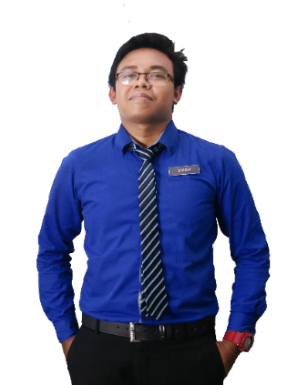

**E-MAIL**

013-2805916

Prof. Dr. Mohamad Suffian Mohamad Annuar

Academic Advisor

Kolej Kediaman Tun Syed Zahiruddin

Universiti Teknologi Mara

[suffian_annuar@um.edu.my](mailto:suffian_annuar@um.edu.my)

+60160-2190 5697

Prof. Dr. Mohamad Suffian Mohamad Annuar

Academic Advisor

Kolej Kediaman Tun Syed Zahiruddin

Universiti Teknologi Mara

[suffian_annuar@um.edu.my](mailto:suffian_annuar@um.edu.my)

+60160-2190 5697

**REFERENCE**

* Graphic Design Award 2015
* Anugerah Guru Cemerlang 2016
* Larian Hari Sukan Negara 2016
* Mount Kinabalu Hiking Expedition
* Volunteer for SUKMA 18
* Creative and Innovation Awards 2017

**ACHIEVEMENT**

**SCIENCE STREAM**

**2009-2010**

**Kedah Matriculation College / Kedah**

**MASTER IN SCIENCE**

**2014 - 2015**

**2010 - 2014**

**BACHELOR OF EDUCATION IN SCIENCE**

**Universiti Teknologi Mara Shah Alam / Selangor**

**Universiti Teknologi Mara Shah Alam / Selangor**

**EDUCATION**

**TEACHER**

**2014 - Running**

**Sekolah Men Keb Kuala Tekal/ Pahang**

Implements curriculum objectives and goals using effective teaching techniques and materials. Develops, in a cooperative manner with the principal and curriculum facilitators, a plan for the improvement and enrichment of instruction.

Implements curriculum objectives and goals using effective teaching techniques and materials. Develops, in a cooperative manner with the principal and curriculum facilitators, a plan for the improvement and enrichment of instruction.

**Sekolah Men Keb Bandar Baru Sungai Buloh/ Selangor**

**2014 - Running**

**TEACHER**

Master’s degree in Science with four years’ experience teaching high school Science, Chemistry, and Additional mathematic. Certification in teaching Science and also professional in graphic design and video editor.

**EXPERIENCE**

**PROFILE**

**GRAPHIC DESIGNER**

**AMIRUL AKMAL**

**Travel**

**Joomla**

**Jquery**

**Wordpress**

Creative Resume, 73480 Puncak Alam, Selangor

**Creative**

**Team Work**

**Cricket**

**Arts**

**Fishing**

**+**

**+**

**+**

**INTERESTS**

**HTML**

**CSS**

**SKILLS**

**PHONE**

resumecreative@yahoo.com

**FACEBOOK**

Facebook.com/Muhd Soleh

**ADDRESS**

**CONTACT**